Task on CloudFront & Route 53

- Configure VPC peering in cross regions.
Objective:
To create two VPCs located in different AWS regions (N. Virginia and Ohio) & do the VPC peering between two VPCs using private IP addresses.
Prerequisite:
VPC - 02
Public subnet – 02

Purpose:
- To enable secure communication between VPCs across regions
- To avoid public internet exposure
- To improve network performance and reduce latency
- To connect distributed applications across AWS regions
Steps:
    - Login as root user to AWS Console
    - Select region as N.Virginia
    - Open Amazon VPC
    - Go to Your VPCs
    - Click Create VPC & then select VPC Only
    - I ‘ll name it as VPC-Virginia
    - IPv4 CIDR block: 10.0.0.0/16 & then create VPC
    - For subnet Go to Subnets & Click Create subnet.
    - Select VPC as VPC-Virginia & subnet as public-subnet-Virginia
    - Availability Zone: us-east-1
    - IPv4 CIDR block: 10.0.0.0/24 & click Create subnet.
    - Create Internet Gateway for VPC-Virginia
    - Open Internet Gateways.
    - Click Create internet gateway.
    - Enter: my-igw
    - Create the IGW & attach it to VPC-Virginia
    - Open Route Tables.
    - Select VPC-Virginia & route table.
    - Click Edit Routes
    - Destination: 0.0.0.0/0 Target: Internet Gateway
    - Select region as Ohio
    - Open Amazon VPC
    - Go to Your VPCs
    - Click Create VPC & then select VPC Only
    - I ‘ll name it as Ohio-VPC
    - IPv4 CIDR block: 10.1.0.0/16 & then create VPC
    - For subnet Go to Subnets & Click Create subnet.
    - Select VPC as Ohio-VPC & subnet as Ohio-public-subnet
Availability Zone: us-east-2a
IPv4 CIDR block: 10.1.1.0/24 & click Create subnet.
    - Create Internet Gateway for Ohio-VPC
    - Open Internet Gateways.
    - Click Create internet gateway.
    - Enter: my-igw
    - Create the IGW & attach it to Ohio-VPC
    - Open Route Tables.
    - Select Ohio-VPC & route table.
    - Click Edit Routes
    - Destination: 0.0.0.0/0 Target: Internet Gateway.
- Launch one EC2 instance in N.Virginia region as my-ec2-virginia
- VPC: VPC-Virginia
- Subnet: public-subnet-Virginia
- Auto-assign Public IP: Enabled
- Amazon Linux 2023 AMI & existing key pair and launch an instance
  - Launch one EC2 instance in Ohio region as my-ec2-Ohio
- VPC: VPC-Ohio
- Subnet: Ohio-public-subnet
- Auto-assign Public IP: Enabled
- Amazon Linux 2023 AMI & existing key pair and launch an instance

- Click Create Peering Connection in VPC-Virginia & name as my-pc-virg-ohio.
- Enter requester VPC ID, select as My account & Region as Another region & accepter VPC ID & click create peering connection.
- Now accept the request by changing to Ohio region
- Now update the Route tables in both regions mentioning the CIDR of Ohio region in N.Virgina and select peering connection & its ID & in ohio region RT add the CIDR of N Virginia and select the peering connection and its ID & save
- Now from git bash connect tomy-ec2-virginia instance and ping with the private IPV4 of my-ec2-ohio & we can see the connectivity.

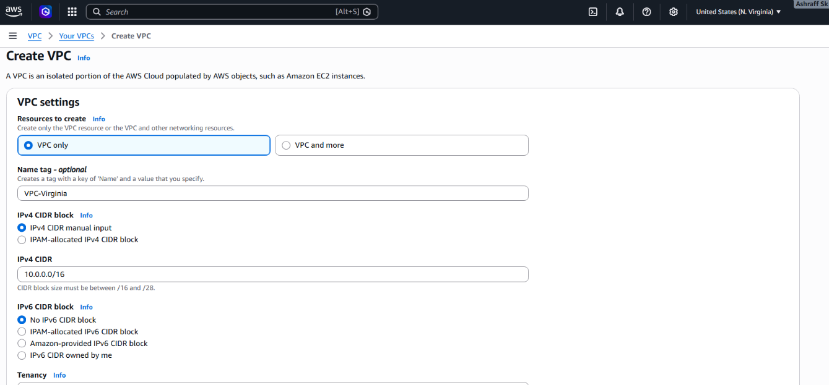

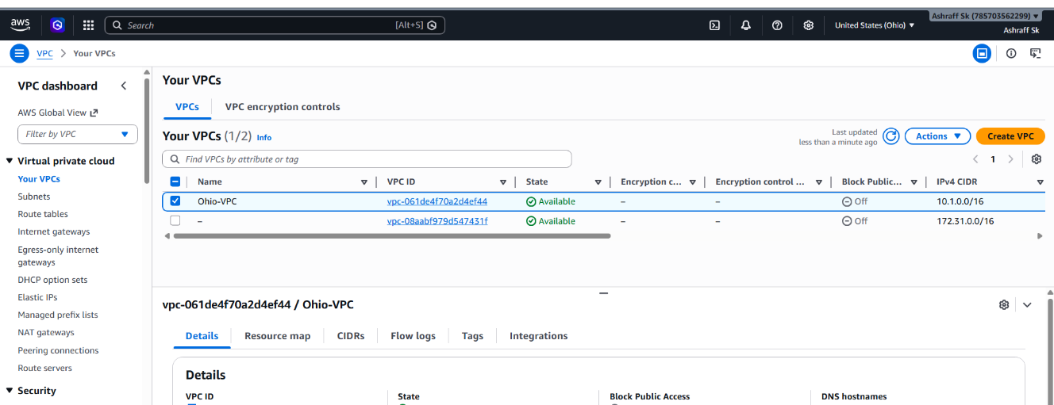

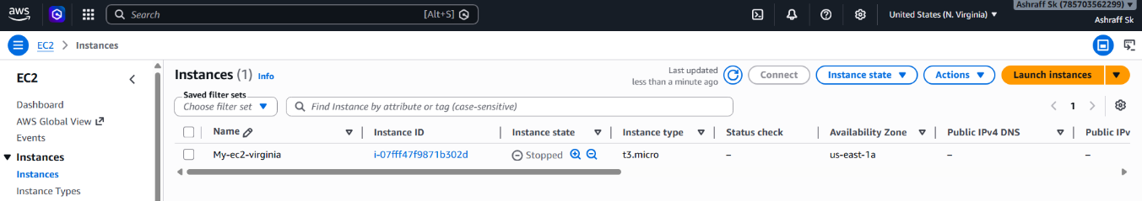

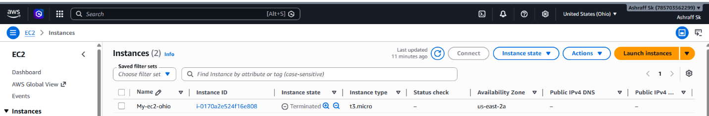
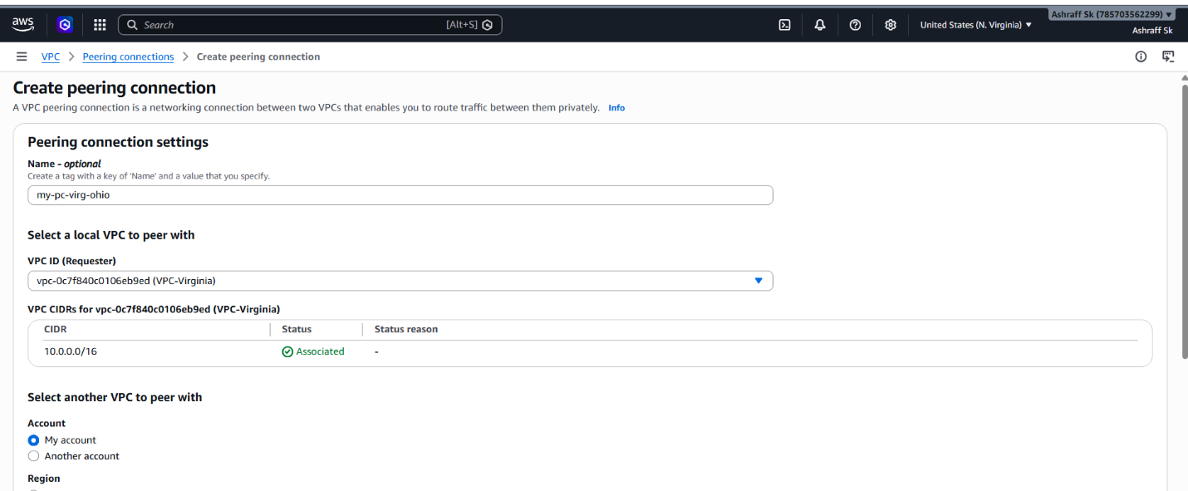
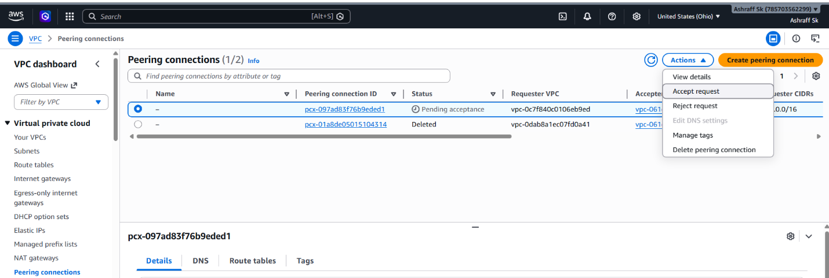
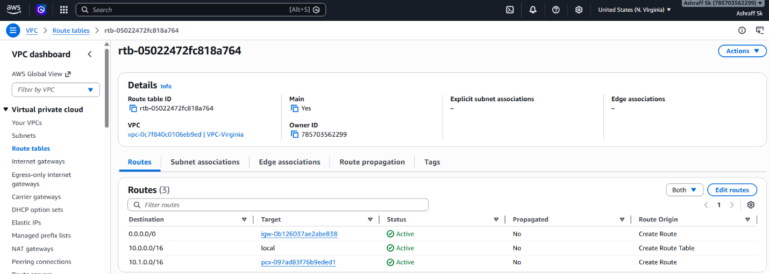
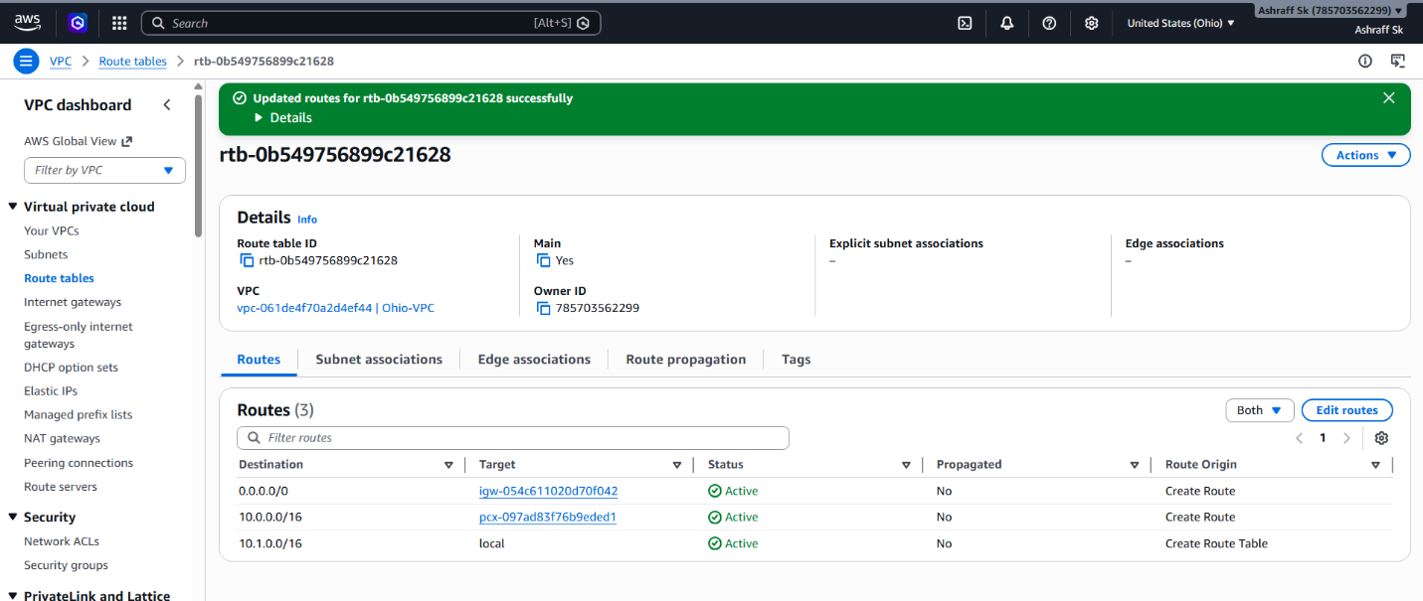

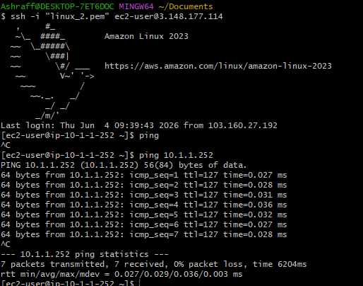

- Purchase one domain from GoDaddy.
Purpose:
The purpose of purchasing a domain from GoDaddy
is to obtain a unique and professional internet address for a website, application or online service.
Objective:
To register and secure a unique domain name
through GoDaddy for establishing an online presence, hosting a website, creating professional email addresses, and building a recognizable brand identity.

Conclusion:
Successfully registered a unique domain name
through GoDaddy, establishing ownership of a web address that can be used for website hosting, professional email services and online brand identity.
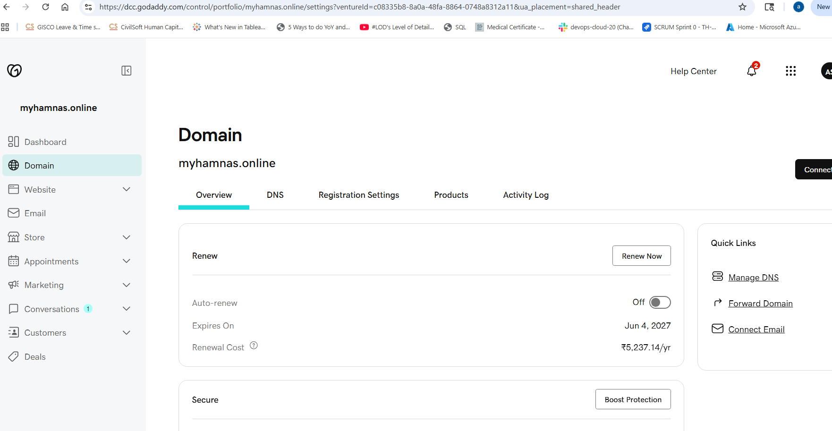

- Deploy static website in S3.
Objective
To host and deploy a static website using Amazon S3 by uploading website files (HTML, CSS, JavaScript, images) and enabling Static Website Hosting

Purpose:
- To understand static website hosting using AWS S3.
- To learn how to configure an S3 bucket for web hosting.
- To make website content accessible through a public URL.

Pre-requisite:
S3 bucket
Steps:
  - We created the s3-bucket-07452 in Task1.
  - Go To S3-bucket Properties & enable Static website hosting.
  - Created index.html & error.html files in our local machine & mention the given names in index document & error document of Edit static website hosting & save.
  - Next upload to s3-bucket-07452 & make as public by selecting make public using ACL under object actions
  - Now we can access the static website using the bucket website url, http://s3-bucket-07452.s3-website-us-east-1.amazonaws.com from s3-bucket properties section
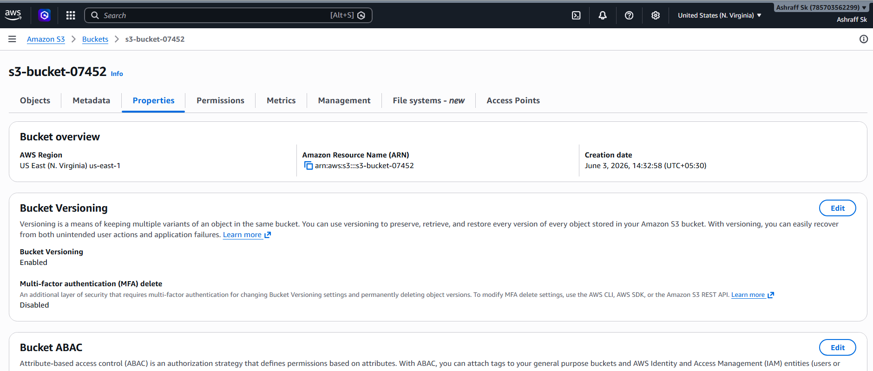
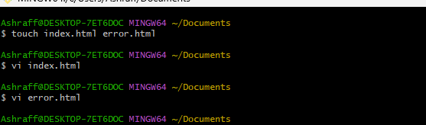
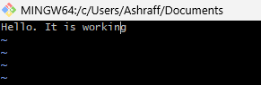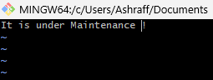

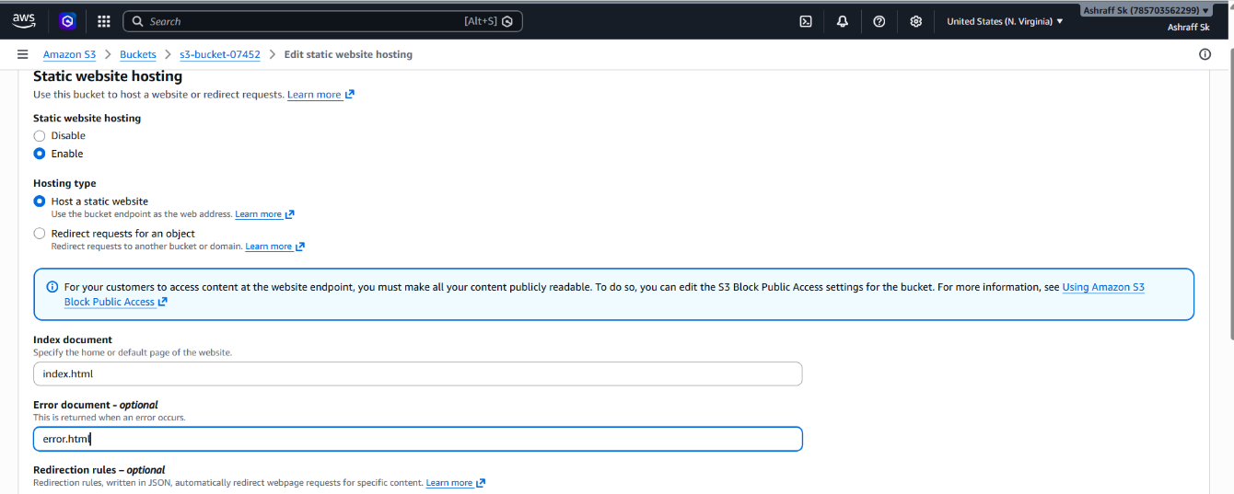
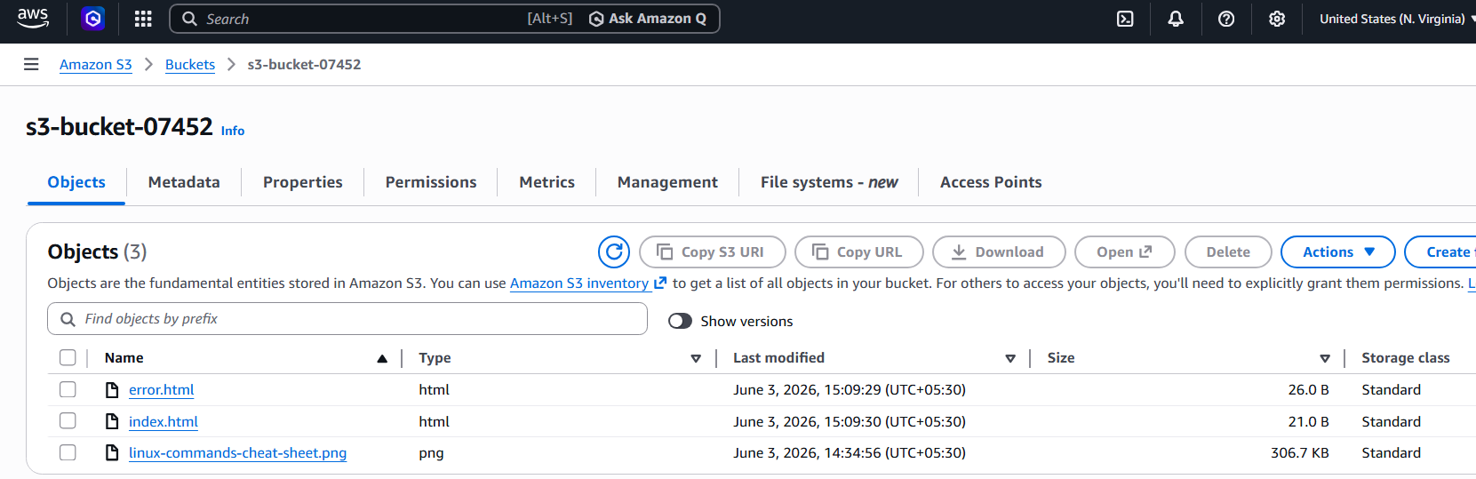
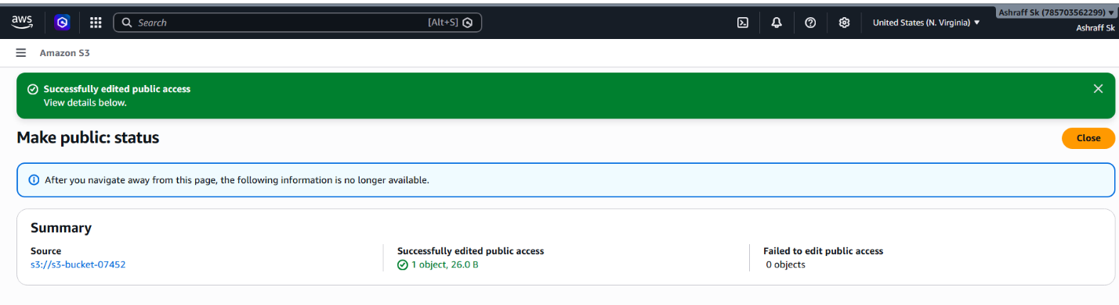

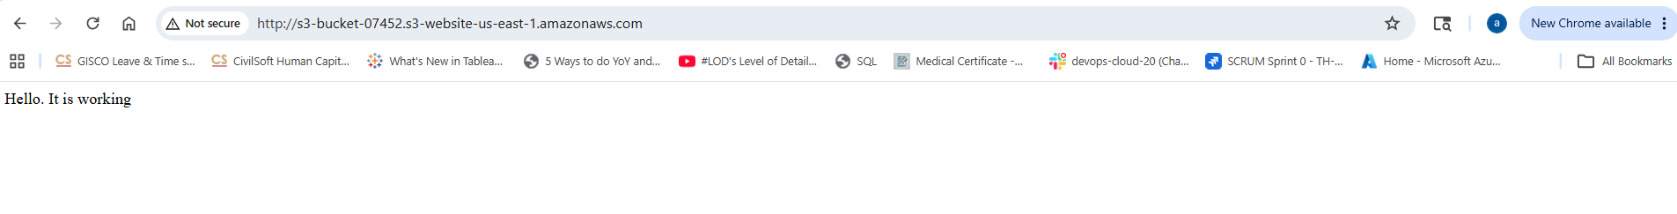
Advantages:
- Low-cost website hosting
- Highly available and durable storage
- No web server management required
- Easy deployment and maintenance
- Suitable for portfolios, landing pages, documentation sites, and static web applications

- Create a CDN and attach one SSL certificate.
Objective:
To create a Content Delivery Network (CDN) using Amazon CloudFront and attach an SSL/TLS certificate to enable secure HTTPS communication for website content delivery.
Purpose:
- To deliver content faster using edge locations worldwide
- To improve website performance and reduce latency
- To secure data using HTTPS (SSL/TLS encryption)
Prerequisites
Domain purchased from GoDaddy (myhamnas.online)
Static website deployed in S3
S3 Website Endpoint available
Step 1: Request SSL Certificate
Navigate
AWS Console
→ Certificate Manager (ACM)
Important:
Switch Region to:
us-east-1 (N. Virginia)
CloudFront only uses ACM certificates from us-east-1.

Click Request Certificate
Select Public Certificate
Enter domain name:myhamnas.online
Click Next
Validation Method as DNS Validation
Click Request
Step 2: Validate Certificate
ACM will provide CNAME records.
Add DNS Record in GoDaddy
Navigate:
GoDaddy
→ My Products
→ Domain
→ DNS Management
Click Add Record
Create ACM-provided CNAME record & Save.
Validation: Usually 5–15 minutes
Status changes to Issued

Step 3: Create CloudFront Distribution
Navigate to AWS Console
→ CloudFront → Create Distribution
Origin Configuration
For Origin Domain:Select S3 Website Endpoint & not the regular S3 bucket endpoint.
Viewer Protocol Policy: Redirect HTTP to HTTPS
Settings:Select Alternate Domain Name
Default Root Object as index.html
Select Custom SSL Certificate
Click on Create Distribution
CloudFront Status:Deploying
Need to wait for 15-20 minutes to become Status as Enabled
CloudFront generates a URL as https://d123abcxyz.cloudfront.net
Open it in browser
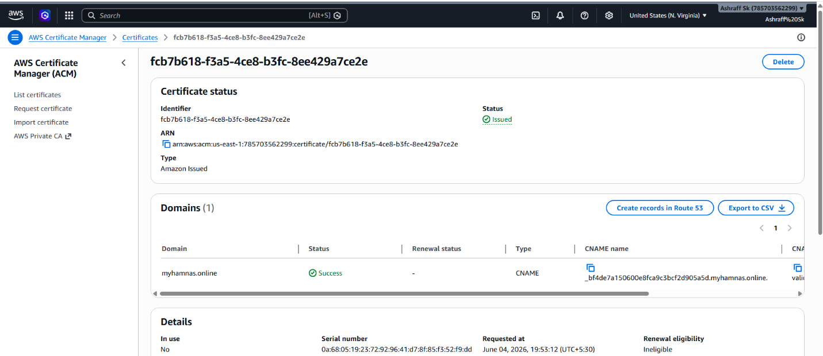

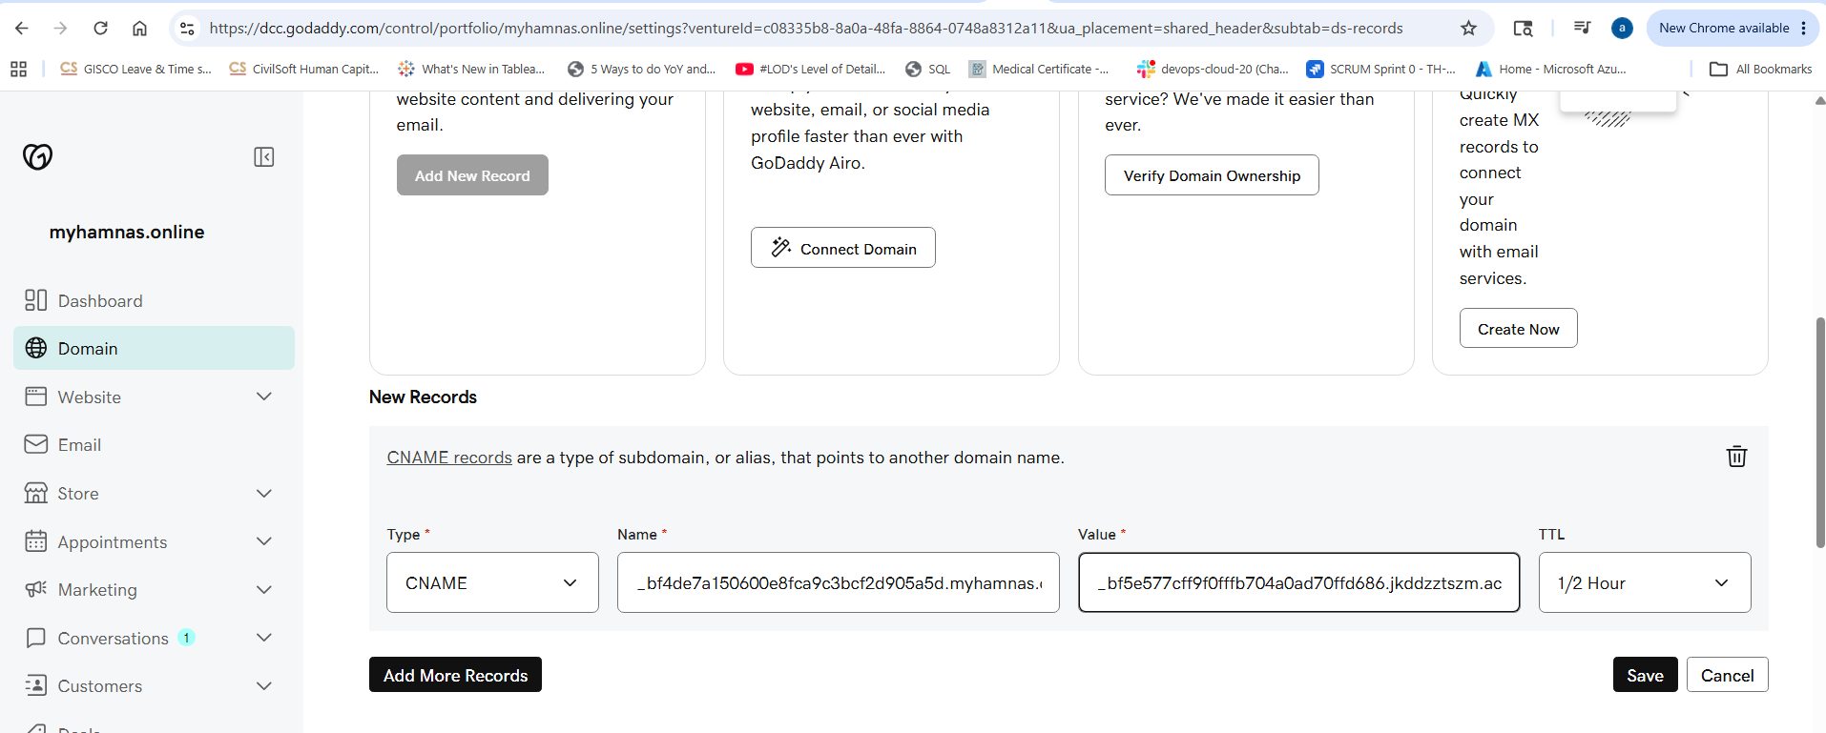

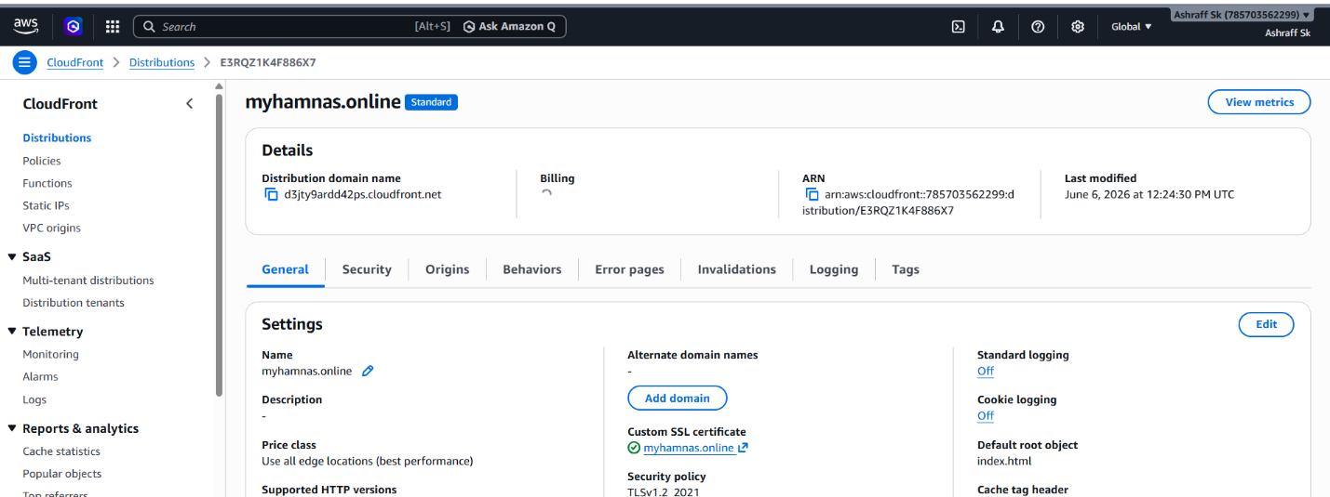
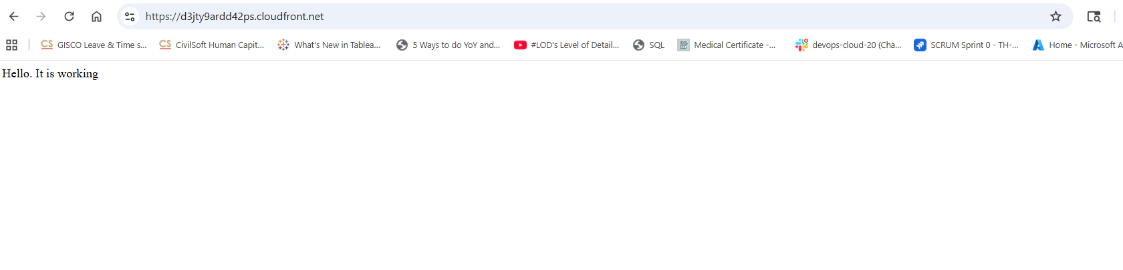
- Create a Route 53 hosted zone and map the domain with the CDN.
Objective
To create a Route 53 Hosted Zone, configure DNS records, and map a custom domain to an Amazon CloudFront CDN distribution for secure and fast global content delivery.

Purpose
- To manage DNS records using AWS Route 53
- To connect a custom domain to CloudFront CDN
- To improve website performance using edge locations

Prerequisites
Registered domain (GoDaddy / Route 53 / etc.)
CloudFront distribution created
SSL certificate in ACM (us-east-1)
S3 bucket or web server as origin
Step 1: Create a Hosted Zone
Navigate to AWS Console
→ Route 53 → Hosted Zones → Create Hosted Zone
Enter Domain Name:myhamnas.online
Type as Public Hosted Zone
Click on Create Hosted Zone
Step 2: Copy Route 53 Name Servers
After creation, Route 53 generates 4 NS records.
Step 3: Update GoDaddy Nameservers
Login to GoDaddy.
Navigate:
My Products
→ Domain: myhamnas.online
→ Domain Settings
→ Nameservers
→ Change
Select as use my own nameservers
Paste the 4 Route 53 nameservers & Save.
Step 5: Create Alias Record in Route 53
Open Route 53
→ Hosted Zones→ myhamnas.online→ Create Record
Configure Record Name as Blank
Record Type as A
Alias as ON
Select as Alias to CloudFront Distribution
Choose d3jty9ardd42ps.cloudfront.net
Click Create Records
Step 6: Create WWW Record (Optional)
Create another record Record Name as www
Record Type as A & Alias as ON
Target as d3jty9ardd42ps.cloudfront.net & Save.
Step 7: Update CloudFront
Go to CloudFront
→ Distribution→ Settings→ Edit
Alternate Domain Name:myhamnas.online
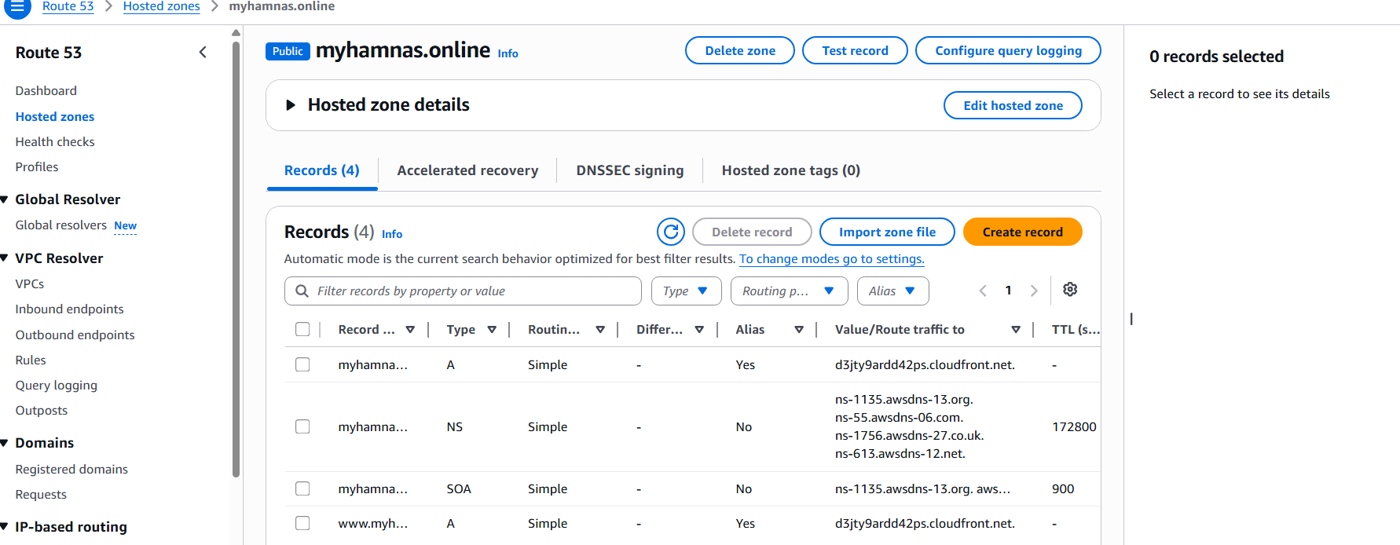
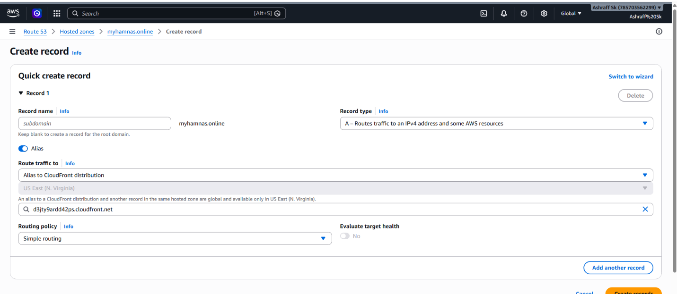
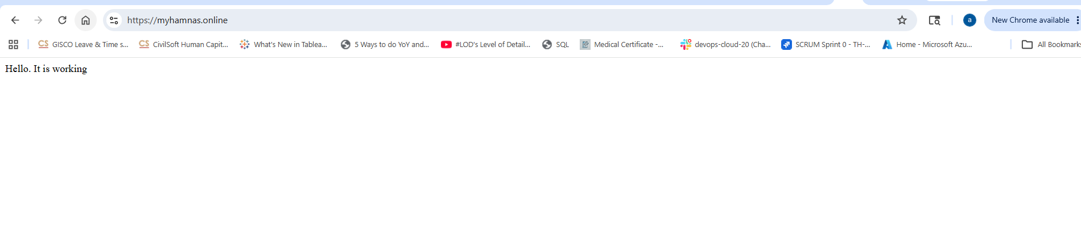
- Update the index.html in the S3 bucket and ensure the updated file is accessible using the domain name.
Objective
Update the existing index.html file in the S3 bucket and verify that the updated content is accessible using the custom domain configured through CloudFront and Route 53.

Step 1: Modify index.html
update the existing index.html file with new content.
Example:
<!DOCTYPE html>
<html>
<head>
<title>Ashraff - Static Website</title>
</head>
<body>
<h1>Welcome to Ashraff’s Static Website</h1>
<p>This website is hosted on Amazon S3.</p>
<p>Delivered through Amazon CloudFront CDN.</p>
<p>Domain managed using Route 53.</p>
<p>Last Updated: June 2026</p>
</body>
</html>
Save the file as:
index.html

Step 2: Upload Updated File to S3
Navigate:
AWS Console → S3 → Bucket → Objects
Select as index.html
→ Add Files→ Select Updated index.html→ Upload
The existing file will be overwritten.
Step 3: Verify S3 Website Endpoint
Open the S3 Static Website URL.
http://s3-bucket-07452.s3-website-us-east-1.amazonaws.com
Verify the updated content is displayed.
Step 4: Clear CloudFront Cache
Since CloudFront caches content, create an invalidation.
Navigate:
AWS Console → CloudFront → Distribution → Invalidations
Click on Create Invalidation
Enter as /*
Click Create Invalidation
Wait for the invalidation status to become Completed.
Step 5: Verify CloudFront URL & custom domain url
Open:
https://d3jty9ardd42ps.cloudfront.net/
https://myhamnas.online/
Verify the updated website content is displayed.
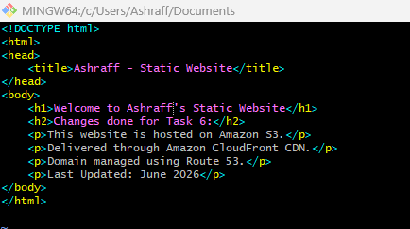
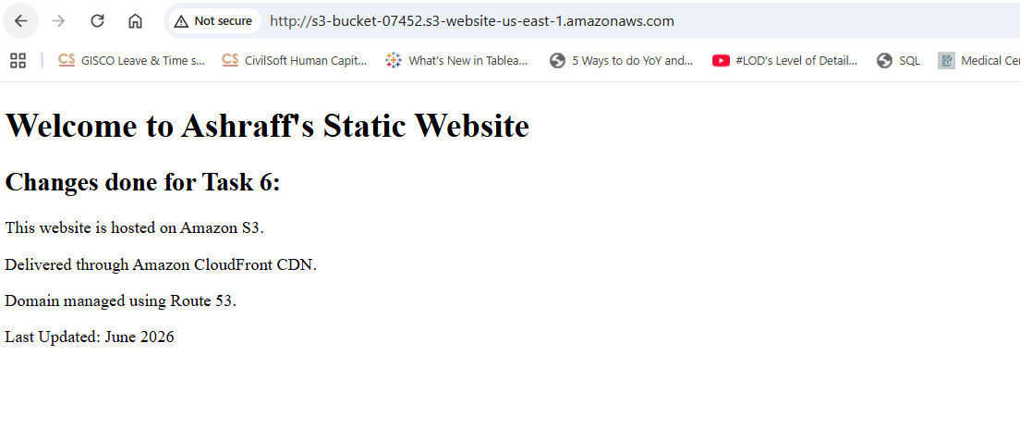
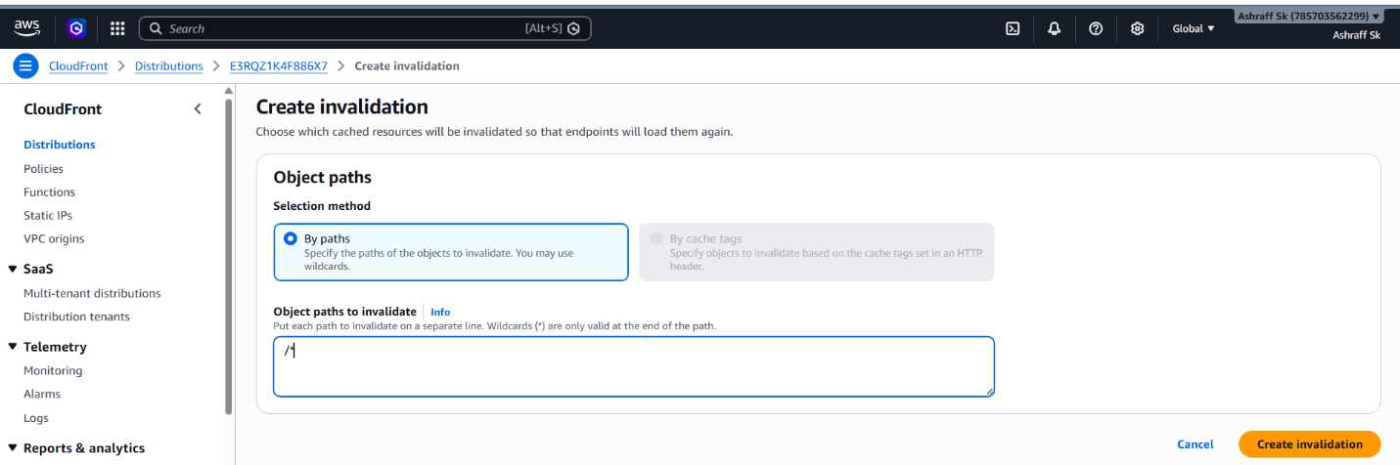

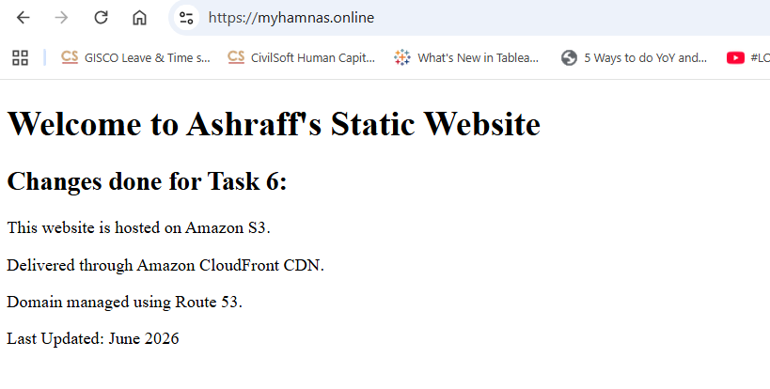
- Share the domain name in Slack to test the connectivity.
Submitted in slack

